**CAR BOOKING RESERVATION USING ZOHO.COM**

STEP 1:

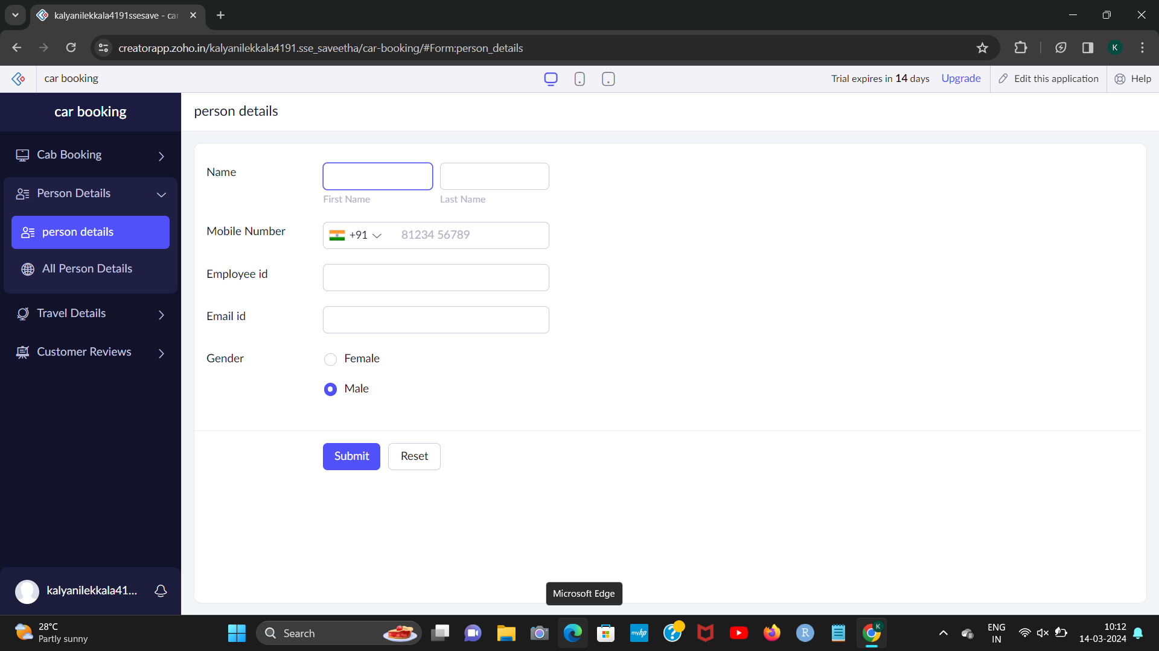

STEP 2:

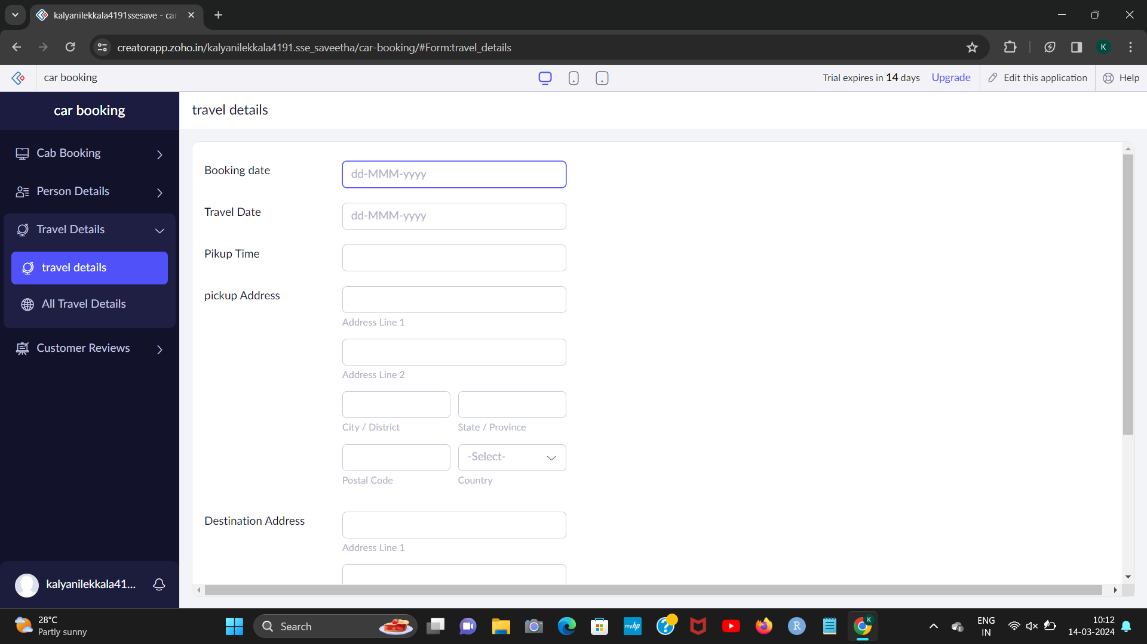

[1]

[2]

STEP 3:

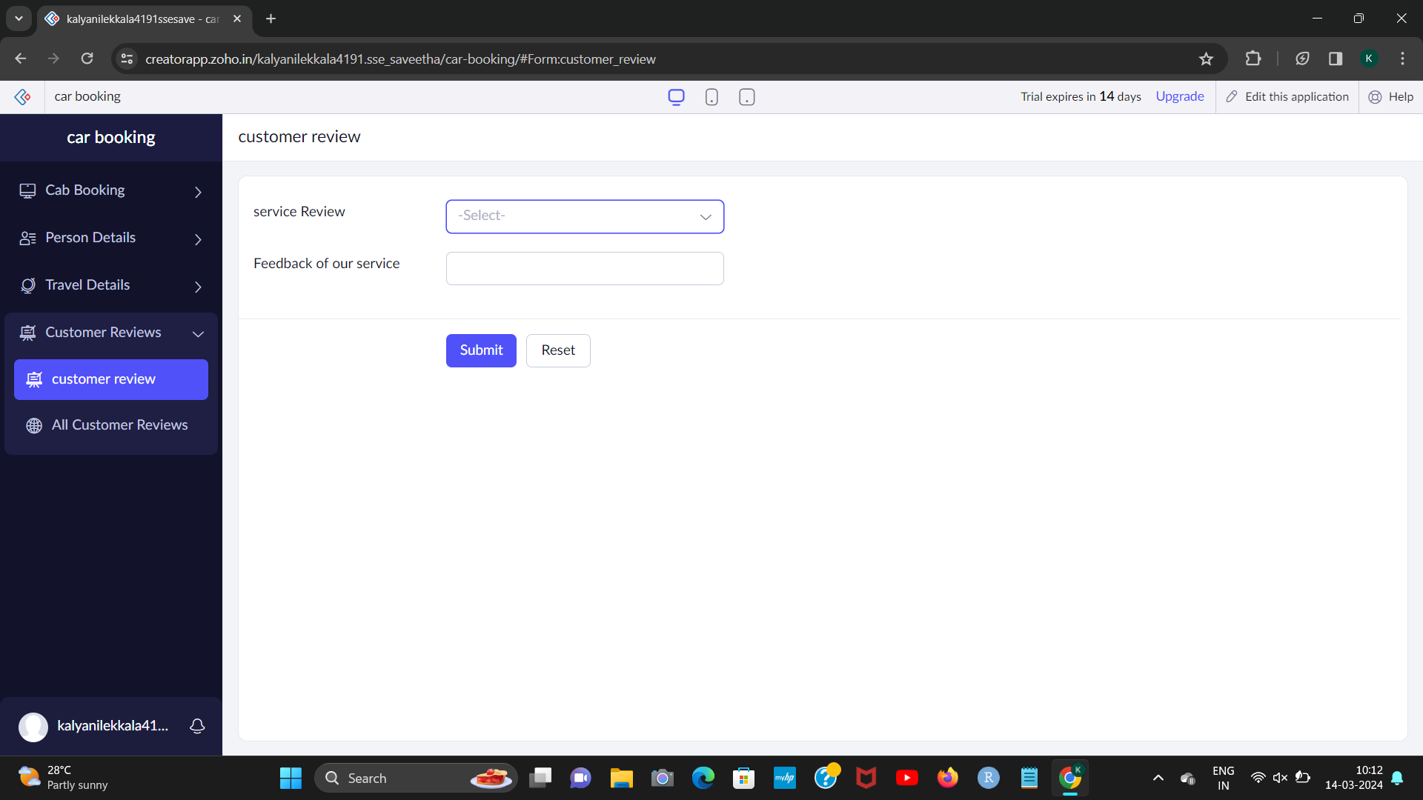

STEP 4:

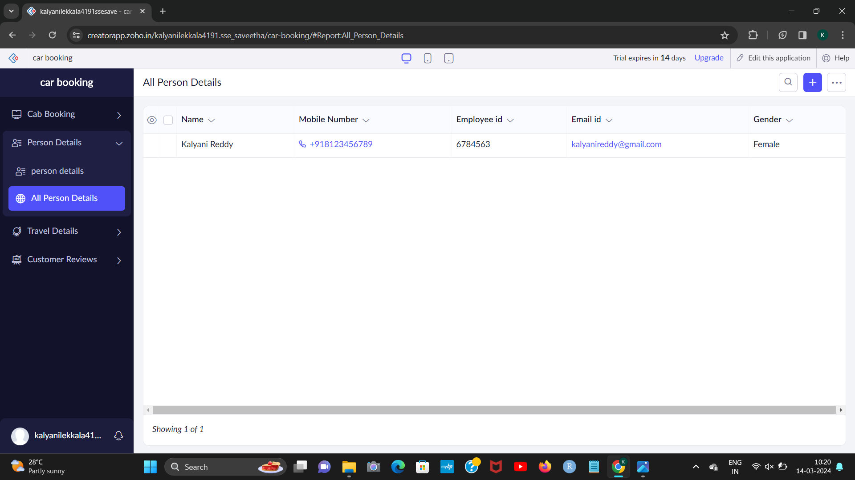

1. L.kalyani 192224191
2. L.kalyani 192224191